Assignment

Stage One Submission

2805ICT/3815ICT/7805ICT

Group Number: _________

Student name:____________ Student ID:___________ Enrolled Course Code: _________

Student name:____________ Student ID:___________ Enrolled Course Code: _________

Student name:____________ Student ID:___________ Enrolled Course Code: _________

Student name:____________ Student ID:___________ Enrolled Course Code: _________

# Table of Contents

Table of Contents 2

1.0 Project Planning and Documentation 3

1.1 Time Schedule 3

1.2 Total working hours 3

1.3 Effort and contribution table 3

1.4 Version Control System 4

2.0 Requirements Analysis 4

2.1 Functional requirements 4

2.2 Non-functional requirements 4

2.3 Use case diagram 4

2.4 Full use case description 4

2.5 Activity diagram 4

3.0 Video link 4

# 1.0 Project Planning and Documentation

## 1.1 Time Schedule

This table should reflect who did what, how long you expected sections to take and the actual hours it took to perform the tasks.

|  |  |  |  |  |  |  |  |  |
| --- | --- | --- | --- | --- | --- | --- | --- | --- |
| **Task** | | **Plan** | | | | **Actual** | | |
| # | Task Name | Student | Planed Time | Cumulative  Time | Finished Date | Time | Cumulative Time | Finished Date |
| 1 | Project plan | Vy Dang |  |  |  |  |  |  |
|  |  |  |  |  |  |  |  |  |
| 2 | Identify Functional Requirement | Vy Dang |  |  |  |  |  |  |
|  |  |  |  |  |  |  |  |  |
|  |  |  |  |  |  |  |  |  |
|  |  |  |  |  |  |  |  |  |
|  |  |  |  |  |  |  |  |  |
|  |  |  |  |  |  |  |  |  |
|  |  |  |  |  |  |  |  |  |
|  |  |  |  |  |  |  |  |  |
|  |  |  |  |  |  |  |  |  |

## 1.2 Total working hours

|  |  |  |
| --- | --- | --- |
| **Student Name (#ID)** | **Plan (hours)** | **Actual (hours)** |
| **S5245519** |  |  |
|  |  |  |
|  |  |  |
|  |  |  |
| **Total working hours** |  |  |
| **Average working hours per person** |  |  |

## 1.3 Effort and contribution table

|  |  |  |  |
| --- | --- | --- | --- |
| **Student** | **Effort Level\***  (Rating from 0 – 5, the information is filled by the group) | **Contribution Level\***  (Rating from 0 – 5, the information is filled by the group) | **Justification**  If a student received level rating of 3 or less, your group need to give explanation for the low level rating |
|  |  |  |  |
|  |  |  |  |
|  |  |  |  |
|  |  |  |  |
| **Total** |  |  |  |

* *Level ratings, 5 = excellent, 4 = good, 3 = reasonable, 2 = poor, 1 = unacceptable, 0 = none

## 1.4 Version Control System

[Your group needs to use a version control system (VCS) to manage the source code development. Please use screenshot to demonstrate that a suitable VCS system has been applied in developing this project. ]

# 2.0 Requirements Analysis

## 2.1 Functional requirements

|  |  |  |  |
| --- | --- | --- | --- |
| **ID** | **Requirement** | **Function** | **Description** |
| FR01 | Start-up Page | Introduce the game | The Start-up Page displays the name of the game “Tetris”, current year, course code and a list of all students in the group of the project. |
| FR02 | Close the game | An “Exit” button on the Start-up Page allows users to close the game |
| FR03 | Display top players | A “Score” button will show the top 10 players with their scores when clicked |
| FR04 | Move to Configure Page | A “Configure” button allows users to access the Configure Page |
| FR05 | Transition to the game interface | A “Play” button that take users to the game interface |
| FR06 | Configure Page | Choose the mode of the game | Users are allowed to choose a normal game or game with an extension |
| FR07 | Select size of the playing field | The size of the playing field, or the space in which the blocks move and stack, is another option available to the players |
| FR08 | Modify the speed of the blocks | The blocks dropping speed can be adjusted by users |
| FR09 | Choose the play mode | Players can choose “Play as AI” option in the Configure Page. |
| FR10 | Game Control | Move left | Left arrow key will shift the falling block to the left |
| FR11 | Move right | Right arrow key will shift the falling block to the right |
| FR12 | Rotate the block | The up arrow key will rotate the block 90 degree clockwise |
| FR13 | Increase the block falling speed | The down arrow key will increase the block falling speed |
| FR14 | Pause the game | Press “P” to pause and resume the game |
| FR15 | Conclude the game | Press “esc” key, a dialog box is prompted and two options are available: “Yes” to return to the Start Page, “No” to keep playing the game |
| FR16 | Toggle music and sound effects | Press “M” to toggle music and sound effects |
| FR17 | Game Scoring | Record points | Points are earned by removing lines, and the number of lines eliminated in a single drop affects how many points players and AI receive. |
| FR18 | Game Extension | Add two types of blocks | In the expanded game version, there will be two new block types with three squares each. |
| FR19 | AI Mode | AI controls the game | Block movements and speed are controlled by the AI in AI Mode. |
| FR20 | Gameplay Page | Display game information | The gameplay page displays the game field, dropping blocks, accumulated blocks, group number, score, eliminated lines, level, game mode, and block shape. |
| FR21 | Game Completion | Lose the game | The game field is filled with blocks |
| FR22 | Exit the game | Press “esc” key and confirm to return to the Start Page |
| FR23 | Record top 10 scores | A dialog box where players can enter their names will appear if their scores rank in the top 10. In AI mode, the name is AI. |

## 2.2 Non-functional requirements

|  |  |  |
| --- | --- | --- |
| **ID** | **Requirement** | **Description** |
| U01 | Usability | The game should have a user-friendly interface that is simple to use and comprehend, accommodating players of all skill levels |
| U02 | Controls, score and game objectives should be explained in detail through game instructions |
| U03 | The layout and behaviour of navigation elements and buttons should remain constant across all of the game’s sections |
| U04 | The game controls should be simple and easy to use to minimise learning time for the players. |
| R01 | Reliability | Even if the game is closed, the high score information should be safely stored |
| R02 | The game should notify the players in case an error occurs |
| R03 | The game should correctly record and update the top 10 high scores |
| R04 | The game should be available for players at any time in a day. |
| P01 | Performance | The buttons in the user interface should response instantly without any lag to user activities |
| P02 | The game should load immediately without significant delays that allows users to play the game shortly after |
| P03 | In the game, block moves and line clearing should be smooth and without twitches or abruptness |
| P04 | The user interface should quickly inform the changes in state of the game to make sure the players receive real-time feedback |
| S01 | Supportability | To make it easier for developers to understand and maintain the game, the code should be well-structured and accompanied by comments |
| S02 | To aid in troubleshooting, the game should record faults and exceptions |
| S03 | Players should be able to report any errors in the game |
| S04 | Analytics should be implemented in the game to gather information on user usage and behaviour, which will help enhance the game in the future |
| SE01 | Security | To avoid tampering or unauthorised modifications, player names and scores kept in high score system should be safely stored. |
| SE02 | The codebase of the game should be examined for vulnerabilities in security |
| SE03 | To avoid snooping in on conversations between players, servers and game elements, encryption is needed. |
| SE04 | Regular security updates and patches are crucial for maintaining player trust and data protection in game |

## 2.3 Use case diagram

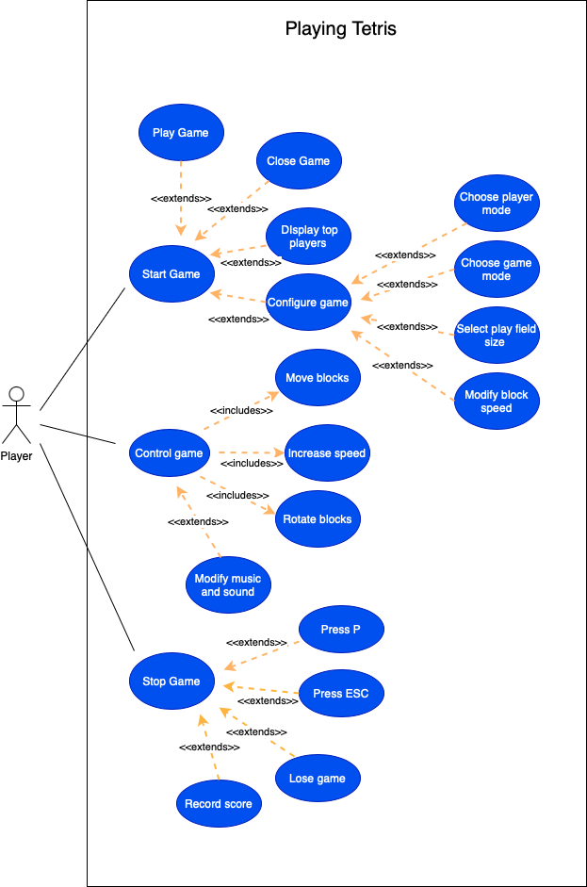

## 2.4 Full use case description

|  |  |  |
| --- | --- | --- |
| **Full Use Case Description** | | |
| **Use Case Name** | Control Tetris Game | |
| **Scenario** | Playing Tetris Game | |
| **Triggering Event** | A player clicks “Play” button to start playing the game | |
| **Brief Description** | The player plays the game by using the arrow keys on the keyboards to control the blocks. | |
| **Actors** | Player | |
| **Related Use Case** | Might be interrupted by “Stop game” use case | |
| **Stakeholders** | Game developers | |
| **Preconditions** | The game is set up and started on the player’s device  The player has reached the game Start-up Page | |
| **Post conditions** | The player must be in top 10 high score, or decide to exit the game, or lose the game  If the player is in top 10 high score, their name and score must be recoded and updated on “Top 10 Players” table | |
| **Flow of Activities** | **Actor** | **Game System** |
| 1. The player click “Play” button 2. The player inputs arrow keys to move the blocks to form lines 3. The player presses “P” to pause the game 4. The player loses the game 5. The player presses “ESC” and confirms to exit the game | * 1. The system transitions to the game interface.   2. The system displays game field, falling blocks and other information related to the player and the game.   3. The system shifts the blocks to the left or right, or rotates the blocks, or increase the block speed.   4. The system shows the next block on the screen.   5. The system eliminates the valid lines.   6. The system updates the number of lines cleared and player score.   3.1 The system pauses and resumes the game  4.1 If player’s score is in top 10, the system pops up a dialog box that allows user to input their name.  4.2 The system returns to the Start-up page   * 1. The system pops up a dialog box for confirmation of the exit   2. The system returns to the Start-up page |
| **Exception Condition** | 1.2 On older device, the game performance degrades  2.1 Player input is invalid | |

## 2.5 Activity diagram

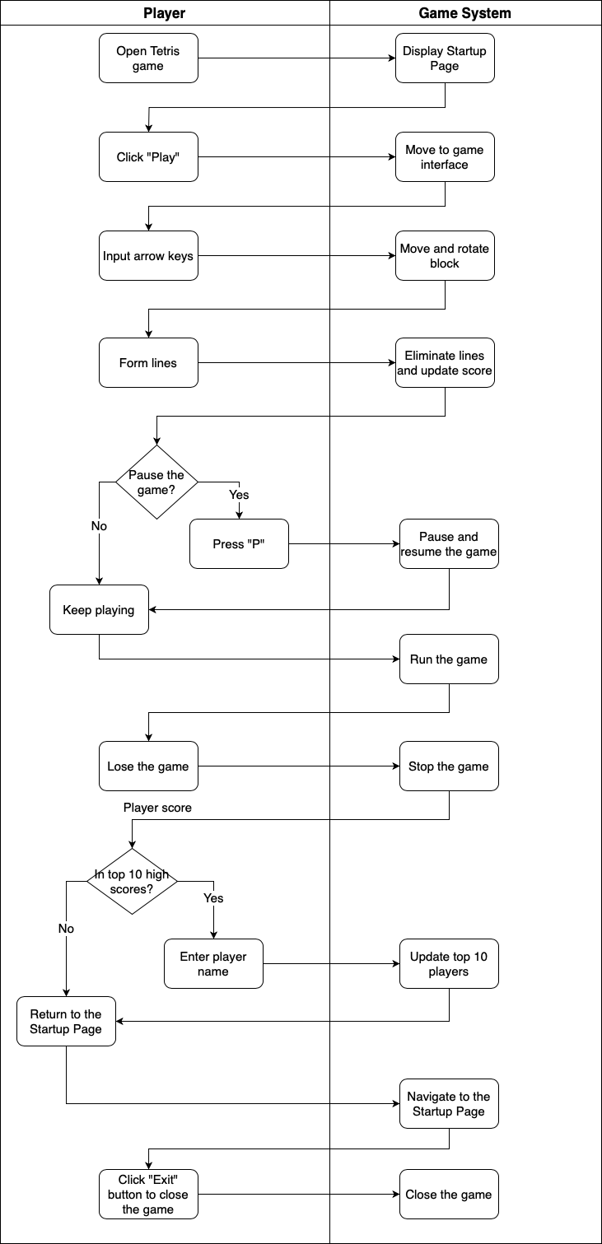

# 3.0 Video link

[please put the URL of your video, and make sure that the video can be viewed by the assessor]